Lab - Designing and Implementing a Subnetted IPv4 Addressing Scheme

1. Topology

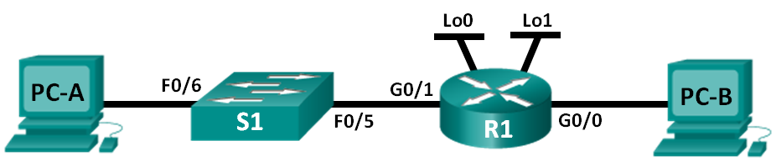

1. Addressing Table

|  |  |  |  |  |
| --- | --- | --- | --- | --- |
| Device | Interface | IP Address | Subnet Mask | Default Gateway |
| R1 | G0/0 |  |  | N/A |
|  | G0/1 |  |  | N/A |
|  | Lo0 |  |  | N/A |
|  | Lo1 |  |  | N/A |
| S1 | VLAN 1 | N/A | N/A | N/A |
| PC-A | NIC |  |  |  |
| PC-B | NIC |  |  |  |

1. Objectives

Part 1: Design a Network Subnetting Scheme

Part 2: Configure the Devices

Part 3: Test and Troubleshoot the Network

1. Background / Scenario

In this lab, starting from a single network address and network mask, you will subnet the network into multiple subnets. The subnet scheme should be based on the number of host computers required in each subnet, as well as other network considerations, like future network host expansion.

After you have created a subnetting scheme and completed the network diagram by filling in the host and interface IP addresses, you will configure the host PCs and router interfaces, including loopback interfaces. The loopback interfaces are created to simulate additional LANs attached to router R1.

After the network devices and host PCs have been configured, you will use the **ping** command to test for network connectivity.

This lab provides minimal assistance with the actual commands necessary to configure the router. However, the required commands are provided in Appendix A. Test your knowledge by trying to configure the devices without referring to the appendix.

**Note**: The routers used with CCNA hands-on labs are Cisco 1941 Integrated Services Routers (ISRs) with Cisco IOS Release 15.2(4)M3 (universalk9 image). The switches used are Cisco Catalyst 2960s with Cisco IOS Release 15.0(2) (lanbasek9 image). Other routers, switches and Cisco IOS versions can be used. Depending on the model and Cisco IOS version, the commands available and output produced might vary from what is shown in the labs. Refer to the Router Interface Summary Table at this end of the lab for the correct interface identifiers.

**Note**: Make sure that the routers and switches have been erased and have no startup configurations. If you are unsure, contact your instructor.

1. Required Resources

* 1 Router (Cisco 1941 with Cisco IOS Release 15.2(4)M3 universal image or comparable)
* 1 Switch (Cisco 2960 with Cisco IOS Release 15.0(2) lanbasek9 image or comparable)
* 2 PCs (Windows 7 or 8 with terminal emulation program, such as Tera Term)
* Console cables to configure the Cisco IOS devices via the console ports
* Ethernet cables as shown in the topology

**Note**: The Gigabit Ethernet interfaces on Cisco 1941 routers are autosensing. An Ethernet straight-through cable may be used between the router and PC-B. If using another Cisco router model, it may be necessary to use an Ethernet crossover cable.

1. Design a Network Subnetting Scheme
   1. Create a subnetting scheme that meets the required number of subnets and required number of host addresses.

In this scenario, you are a network administrator for a small subdivision within a larger company. You must create multiple subnets out of the 192.168.0.0/24 network address space to meet the following requirements:

* The first subnet is the employee network. You need a minimum of 25 host IP addresses.
* The second subnet is the administration network. You need a minimum of 10 IP addresses.
* The third and fourth subnets are reserved as virtual networks on virtual router interfaces, loopback 0 and loopback 1. These virtual router interfaces simulate LANs attached to R1.
* You also need two additional unused subnets for future network expansion.

**Note**: Variable length subnet masks will not be used. All of the device subnet masks will be the same length.

Answer the following questions to help create a subnetting scheme that meets the stated network requirements:

* + - 1. How many host addresses are needed in the largest required subnet? 25 adresses
      2. What is the minimum number of subnets required? 6 subnets
      3. The network that you are tasked to subnet is 192.168.0.0/24. What is the /24 subnet mask in binary?

11111111.11111111.11111111.00000000

* + - 1. The subnet mask is made up of two portions, the network portion, and the host portion. This is represented in the binary by the ones and the zeros in the subnet mask.

In the network mask, what do the ones represent? Network partition

In the network mask, what do the zeros represent? Host partition

* + - 1. To subnet a network, bits from the host portion of the original network mask are changed into subnet bits. The number of subnet bits defines the number of subnets. Given each of the possible subnet masks depicted in the following binary format, how many subnets and how many hosts are created in each example?

**Hint**: Remember that the number of host bits (to the power of 2) defines the number of hosts per subnet (minus 2), and the number of subnet bits (to the power of two) defines the number of subnets. The subnet bits (depicted in bold type face) are the bits that have been borrowed beyond the original network mask of /24. The /24 is the slash prefix notation and corresponds to a dotted decimal mask of 255.255.255.0.

(/25) 11111111.11111111.11111111.**1**0000000

Dotted decimal subnet mask equivalent: 255.255.255.128

Number of subnets? 2^1 bit = 2_, Number of hosts? _2^7zeros -2=126

(/26) 11111111.11111111.11111111.**11**000000

Dotted decimal subnet mask equivalent: _255.255.255.192

Number of subnets? 4_______, Number of hosts? _____2^6zeros -2 = 62

(/27) 11111111.11111111.11111111.**111**00000

Dotted decimal subnet mask equivalent: __255.255.255.224_

Number of subnets? _8_ Number of hosts? 30_

(/28) 11111111.11111111.11111111.**1111**0000

Dotted decimal subnet mask equivalent: _255.255.255.240

Number of subnets? ___16_____ Number of hosts? ___14__

(/29) 11111111.11111111.11111111.**11111**000

Dotted decimal subnet mask equivalent: __255.255.255.248

Number of subnets? ___32_____ Number of hosts? ___6__

(/30) 11111111.11111111.11111111.**111111**00

Dotted decimal subnet mask equivalent: ______255.255.255.252___

Number of subnets? ___64______ Number of hosts? _____2______

* + - 1. Considering your answers, which subnet masks meet the required number of minimum host addresses?

____________________________27=30;26=62;28=126___________________________________________we need 25

* + - 1. Considering your answers, which subnet masks meets the minimum number of subnets required?

27;28;29;30

* + - 1. Considering your answers, which subnet mask meets both the required minimum number of hosts and the minimum number of subnets required?

___________________27________________________________________

* + - 1. When you have determined which subnet mask meets all of the stated network requirements, you will derive each of the subnets starting from the original network address. List the subnets from first to last below. Remember that the first subnet is 192.168.0.0 with the newly acquired subnet mask.

**Subnet Address / Prefix Subnet Mask (dotted decimal)**

___________________ / ____ __________________________

___________________ / ____ __________________________

___________________ / ____ __________________________

___________________ / ____ __________________________

___________________ / ____ __________________________

___________________ / ____ __________________________

___________________ / ____ __________________________

___________________ / ____ __________________________

___________________ / ____ __________________________

___________________ / ____ __________________________

* 1. Complete the diagram showing where the host IP addresses will be applied.

On the following lines provided, fill in the IP addresses and subnets masks in slash prefix notation. On the router, use the first usable address in each subnet for each of the interfaces, Gigabit Ethernet 0/0, Gigabit Ethernet 0/1, loopback 0, and loopback 1. Fill in an IP address for both PC-A and PC-B. Also enter this information into the Addressing Table on Page 1.

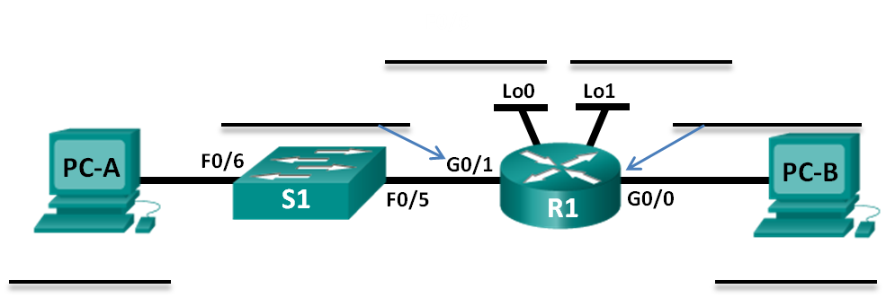

1. Configure the Devices

In Part 2, set up the network topology and configure basic settings on the PCs and router, such as the router Gigabit Ethernet interface IP addresses, and the PC’s IP addresses, subnet masks, and default gateways. Refer to the Addressing Table for device names and address information.

**Note**: Appendix A provides configuration details for the steps in Part 2. You should attempt to complete Part 2 prior to reviewing Appendix A.

* 1. Configure the router.
     1. Enter into privileged EXEC mode and then global config mode.
     2. Assign the **R1** as the hostname for the router.
     3. Configure both the **G0/0** and **G0/1** interfaces with IP addresses and subnet masks, and then enable them.
     4. Loopback interfaces are created to simulate additional LANs on R1 router. Configure the loopback interfaces with IP addresses and subnet masks. After they are created, loopback interfaces are enabled, by default. (To create the loopback addresses, enter the command **interface loopback 0** at the global config mode)

**Note**: You can create additional loopbacks for testing with different addressing schemes, if desired.

* + 1. Save the running configuration to the startup configuration file.
  1. Configure the PC interfaces.
     1. Configure the IP address, subnet mask, and default gateway settings on PC-A.
     2. Configure the IP address, subnet mask, and default gateway settings on PC-B.

1. Test and Troubleshoot the Network

In Part 3, you will use the **ping** command to test network connectivity.

* + 1. Test to see if PC-A can communicate with its default gateway. From PC-A, open a command prompt and ping the IP address of the router Gigabit Ethernet 0/1 interface. Do you get a reply? ___YES____
    2. Test to see if PC-B can communicate with its default gateway. From PC-B, open a command prompt and ping the IP address of the router Gigabit Ethernet 0/0 interface. Do you get a reply? ___YES_____
    3. Test to see if PC-A can communicate with PC-B. From PC-A, open a command prompt and ping the IP address of PC-B. Do you get a reply? YES
    4. If you answered “no” to any of the preceding questions, then you should go back and check all of your IP address and subnet mask configurations, and ensure that the default gateways have been correctly configured on PC-A and PC-B.
    5. If you verify that all of the settings are correct, and you can still not ping successfully, then there are a few additional factors that can block ICMP pings. On PC-A and PC-B within Windows, make sure that the Windows Firewall is turned off for the Work, Home, and Public networks.
    6. Experiment by purposely misconfiguring the gateway address on PC-A to 10.0.0.1. What happens when you try and ping from PC-B to PC-A? Do you receive a reply?

____No request timed out_________________________________________________________

____________________________________________________________________________________

1. Reflection
   1. Subnetting one larger network into multiple smaller subnetworks allows for greater flexibility and security in network design. However, what do you think some of the drawbacks are when the subnets are limited to being the same size?

______some subnetworks need a lot of ip addresses and others require only a few, having all the subnets the same size is not the most effectient way to devide the subnets__________________________________________________________________________

* 1. Why do you think the gateway/router IP address is usually the first usable IP address in the network?

_____________________the router or getaway is a gate(or door)of the network and that because there is the last or first address in the network_______________________________

1. Router Interface Summary Table

|  |  |  |  |  |
| --- | --- | --- | --- | --- |
| Router Interface Summary | | | | |
| Router Model | Ethernet Interface #1 | Ethernet Interface #2 | Serial Interface #1 | Serial Interface #2 |
| 1800 | Fast Ethernet 0/0 (F0/0) | Fast Ethernet 0/1 (F0/1) | Serial 0/0/0 (S0/0/0) | Serial 0/0/1 (S0/0/1) |
| 1900 | Gigabit Ethernet 0/0 (G0/0) | Gigabit Ethernet 0/1 (G0/1) | Serial 0/0/0 (S0/0/0) | Serial 0/0/1 (S0/0/1) |
| 2801 | Fast Ethernet 0/0 (F0/0) | Fast Ethernet 0/1 (F0/1) | Serial 0/1/0 (S0/1/0) | Serial 0/1/1 (S0/1/1) |
| 2811 | Fast Ethernet 0/0 (F0/0) | Fast Ethernet 0/1 (F0/1) | Serial 0/0/0 (S0/0/0) | Serial 0/0/1 (S0/0/1) |
| 2900 | Gigabit Ethernet 0/0 (G0/0) | Gigabit Ethernet 0/1 (G0/1) | Serial 0/0/0 (S0/0/0) | Serial 0/0/1 (S0/0/1) |
| **Note**: To find out how the router is configured, look at the interfaces to identify the type of router and how many interfaces the router has. There is no way to effectively list all the combinations of configurations for each router class. This table includes identifiers for the possible combinations of Ethernet and Serial interfaces in the device. The table does not include any other type of interface, even though a specific router may contain one. An example of this might be an ISDN BRI interface. The string in parenthesis is the legal abbreviation that can be used in Cisco IOS commands to represent the interface. | | | | |

1. Appendix A: Configuration Details for Steps in Part 2
   1. Configure the router.
      1. Console into the router and enable privileged EXEC mode.

Router> **enable**

Router#

* + 1. Enter into configuration mode.

Router# **conf t**

Enter configuration commands, one per line. End with CNTL/Z.

Router(config)#

* + 1. Assign a device name to the router.

Router(config)# **hostname R1**

R1(config)#

* + 1. Configure both the **G0/0** and **G0/1** interfaces with IP addresses and subnet masks, and enable them.

R1(config)# **interface g0/0**

R1(config-if)# **ip address <ip address> <subnet mask>**

R1(config-if)# **no shutdown**

R1(config-if)# **interface g0/1**

R1(config-if)# **ip address <ip address> <subnet mask>**

R1(config-if)# **no shutdown**

* + 1. Loopback interfaces are created to simulate additional LANs off of router R1. Configure the loopback interfaces with IP addresses and subnet masks. When they are created, loopback interfaces are enabled, by default.

R1(config)# **interface loopback 0**

R1(config-if)# **ip address <ip address> <subnet mask>**

R1(config-if)# **interface loopback 1**

R1(config-if)# **ip address <ip address> <subnet mask>**

R1(config-if)# **end**

* + 1. Save the running configuration to the startup configuration file.

R1# **copy running-config startup-config**

* 1. Configure the PC interfaces.
     1. Configure the IP address, subnet mask, and default gateway settings on PC-A.

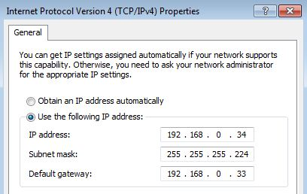

* + 1. Configure the IP address, subnet mask, and default gateway settings on PC-B.

